# **Forward Propagation in a single layer**

Computing the activation function a1

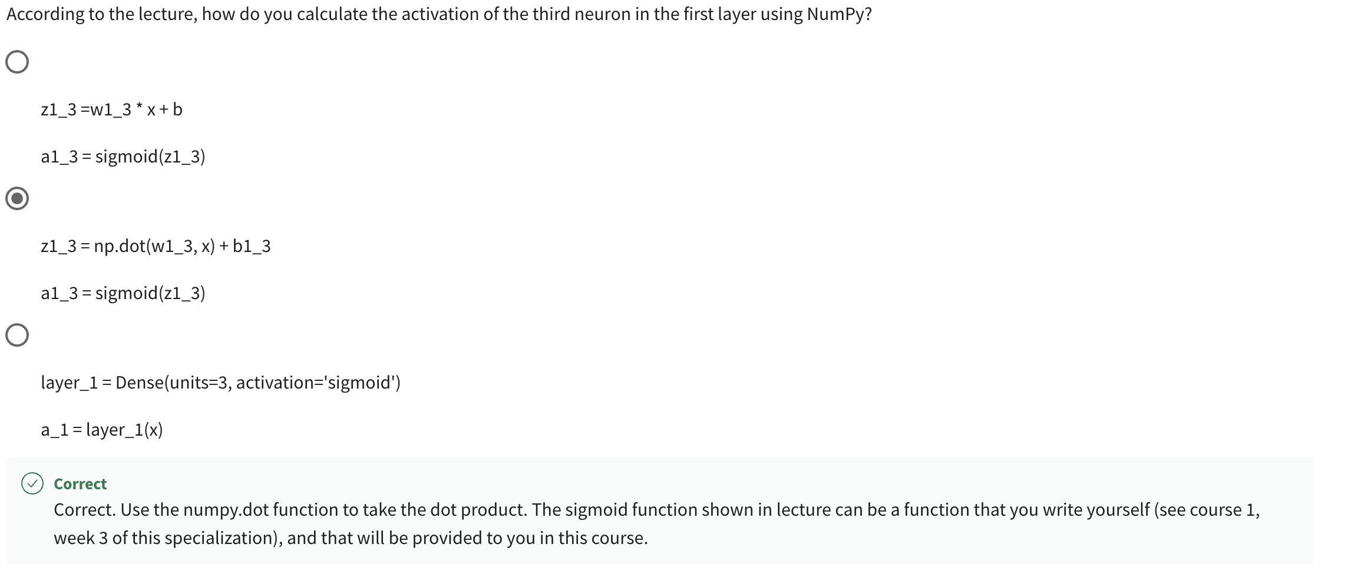

Computing the activation function a2

# **General Implementation of Forward Propagation**

def dense() 🡪 A single layer in the neural network

a_in from the previous layer || W,b in the present layer

Loops through all the units in that hidden layer

a1 output is fed into a2 = dense(a1, W2, b2)

a2 output is fed into a3 = dense(a2, W3, b3)  
a3 output is fed into a4 = dense(a3, W4, b4)

Our example consists only 1 hidden layer, But in RHS it is mentioned nearly to 4 hidden layer.

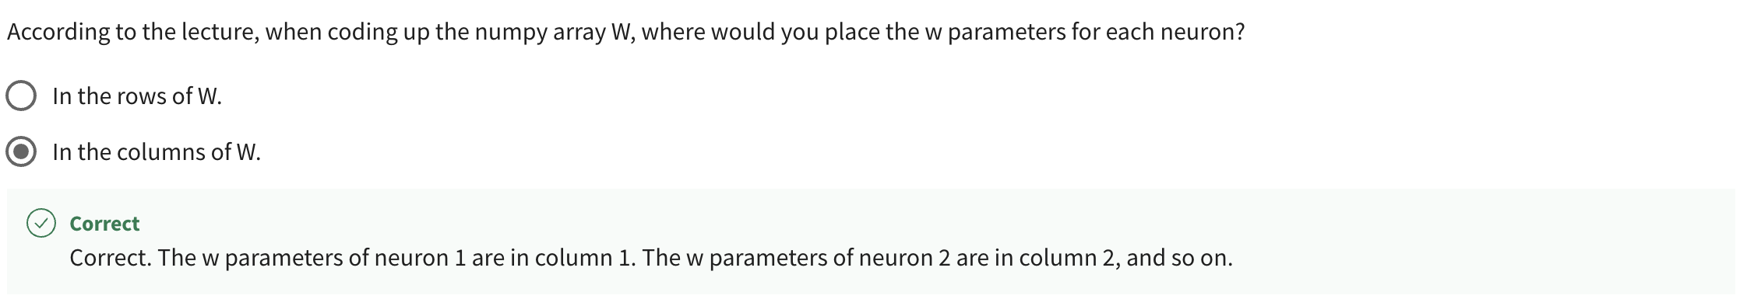

# **LAB 🡪 Coffee Roasting in Numpy**

Refer 2_CoffeeRoasting_Numpy.ipynb

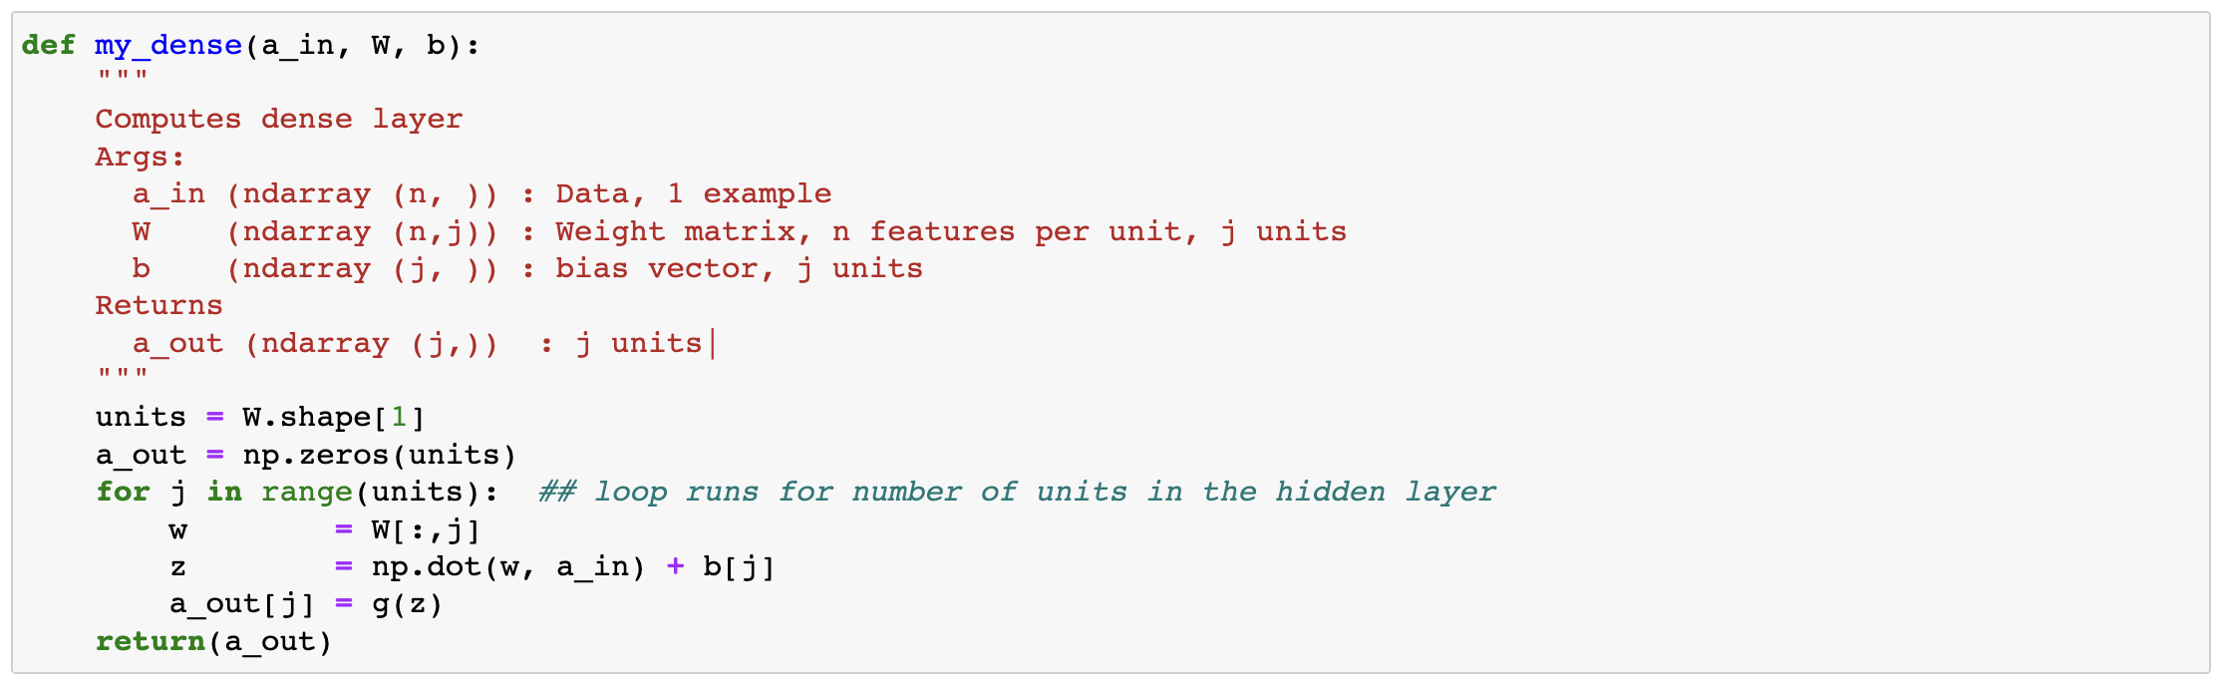  


# **Quiz**